**Syllabus:**

**BIO 142 – Foundations: Organismal Biology**

**Block 4, 2018**

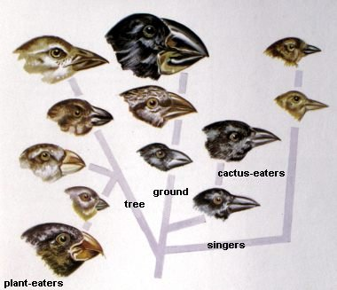 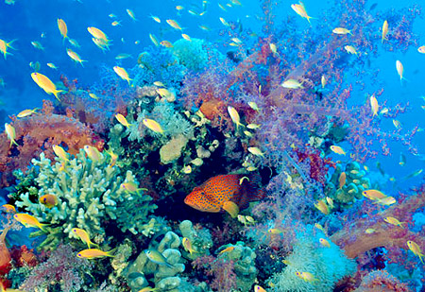 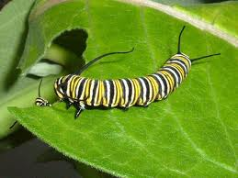

**INSTRUCTORS**

**Tammy Mildenstein Becky Richtsmeier**

West Science 108A West Science 113

Phone: 319-895-4494 (office); 406-214-1563 (cell) Phone: 319-895-4375 (office)

Email: [tmildenstein@cornellcollege.edu](mailto:tmildenstein@cornellcollege.edu) Email: Brichtsmeier@cornellcollege.edu

Office Hours: before or after class, or by appointment Office Hours: during lunch break or by

appointment

**Meeting times:** 9:00 – 11:00 AM, 1:00 – 3:00 PM; , Russell Science Hall, Room 123

Times and locations of field trips will vary.

**Required textbook and readings**

You will need the following materials:

* **The Beak of the Finch**: The Story of Evolution in our Time. (Jonathon Weiner, New York:Alfred A. Knopf, **1994**. 332 pp)
* Supplemental readings will be provided throughout the semester on Moodle

**OPTIONAL**: **Biological Science, 5th Edition.** (Scott Freeman, Benjamin Cummings, 2011. New York.)

**Course description**

This course introduces topics of genetics, evolution, speciation, classification, the diversity of life, ecology, and biological communities. The course is a prerequisite for all upper-level Biology courses. (Laboratory Science) –Cornell College course catalogue.

Nothing in biology makes sense except in light of evolution – Theodosius Dobzhansky 1973

**The diversity of life forms**, **so numerous** that we have yet to identify most of them, is the

greatest wonder of this planet -- E.O. Wilson, 1988

All things are bound together. All things connect. -- Chief Seattle, 1855

Course objectives

My goals for this course include the following:

* to investigate biological concepts on local and global scales
* to cultivate reading and writing skills within the scientific literature
* to strengthen students’ critical thinking skills
* to impart a conservation ethic with respect to the environment
* to provide opportunities for hands-on learning using field and lab techniques
* to deepen students’ sense of place by tying this course directly to local biology

Students will become familiar with Evolution, Biodiversity and Ecology. Specifically, we will study:

* the genetic basis of evolutionary change
* the processes by which new species arise
* differences among major taxonomic groups
* factors that influence the distribution and abundance of organisms
* ecosystems and biological communities
* how organisms interact with and affect each other

*This course supports the* ***Educational Priorities and Outcomes of Cornell College*** *with emphases on knowledge, inquiry, reasoning, communication, ethical behavior, citizenship, vocation, and well-being.* These *Educational Priorities and Outcomes* can be found in the Academic Catalogue

*Knowledge*: The course will introduce you to ecological concepts using examples from local, national, and international case studies.

*Inquiry and reasoning:* My goal is to guide the class in developing and conducting a inquiry-based project on local biology. In the process, we will read and critique the peer reviewed literature in biology and gain a background on different approaches to biological study.

*Communication*: Students will work in small groups to develop their own biological research projects. For this project, students will need to collaborate with their peers to develop a proposal for their study, present their project ideas, conduct primary research, and present their project results to the group in both oral and written form. Students will be asked to lead in-class discussions and be prepared to ask questions in lectures, guest lectures, and discussions led by their peers.

*Ethical behavior*: As members of the local ecosystem ourselves, we will discuss and practice environmental conservation ethics.

*Citizenship and vocation*: Students will learn how the research they are conducting informs conservation of natural resources. Meeting local protected area managers will provide examples of career opportunities in conservation bioogy.

*Well-being:* Exploration and recreation outside have been linked to greater creativity and a sense of well-being

**Readings and Textbook:** In addition to the required text books, there will be required readings, the information from which will be testable. Any required readings will be placed on the course website before lectures. I also have a copy of a general biology text book in the classroom that may be looked at and copied. Please do not take this copy out of the classroom.

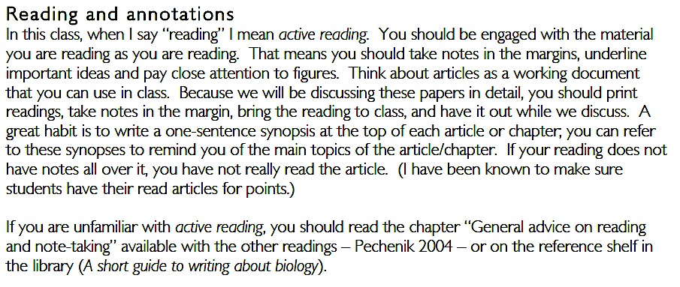

**Website:** We will be using Moodle as our course website. Once you are registered for the course, you can login to access lectures, assigned readings, and other course documents.

**Class Format:** This class will make use of lectures, student-led discussions, small group projects, and field trips to impart important principles of ecology and provide opportunities to get involved in a meaningful way.

LECTURES will be given by me (the instructor) as well as by guest lecturers who are professionals in the field of biology. Instructor lectures will be primarily PowerPoint based and made available on the course Moodle website AFTER lectures for downloading and reviewing. Discussion of assigned readings will be included. Guest speakers will be given their choice of teaching format. Whenever possible, we will request copies of their presentation material, but this is not guaranteed.

STUDENT-LED DISCUSSIONS will provide students with a way to present material they learned to the class and engage classmates in discussion about the material. Each student will be asked to lead a discussion/present material at least twice this block.

CLASS PROJECTS for this class will be to conduct biological studies of your choice. With 2 partners you will choose a question to study, make hypotheses, collect data, analyze and interpret data, and make suggestions for further research. A large part of your final grade will be based on the project report.

FIELD TRIPS to local natural areas/displays will be once/week. As much as possible, field trips will take place during regular class hours. Most field trips will take place over lunch break, but these will be announced in advance. If a field trip will result in an early departure and/or late return to campus, we will let you know well in advance.

All material covered (i.e. not just powerpoint lectures) will be considered testable class content.

**Class participation:** A substantial part of your grade and most of your success in this class will be based on your ability to prepare for class and contribute to discussions. In classes like this with group projects, participation is of utmost importance. Because you will be working in small groups, your peers will also be asked to weigh in on your participation grade, and you will be asked to rate your peers.

**In-class quizzes/assignments:** We will have at least five, in-class quizzes assignments this Block (5-10 pts each). One of the in-class assignment will be for each student to bring in a current events article about biology to present in the class. A schedule of in-class presentations on current events will be finalized on the first day of class.

Other assignments may include any of the following: unannounced quizzes on recent reading material, writing assignments based on class project, writing about or leading a discussion on: 1) the day’s reading topic, 2) review of recent lectures, 3) review of a lab.

Assignments are due at 5:00 pm on the day they are scheduled to be submitted, unless otherwise noted. Late assignments will be reduced by 1 letter grade for each day they are submitted after the deadline, starting at 5:00 pm on the due date.

**Laboratory assignments:** We will conduct 3 lab projects, for which you will make a hypothesis, collect data, and interpret your results. These experiments will be designed by the course. Your grade for these will be based on your understanding of the concepts studied, as exemplified by your lab report. Lab reports are expected to be well-written, complete, and full of your own critical thinking and contributions.

**Group projects:** In groups of 3-4, students will be responsible for cooperating in the research on a topic of their own choosing. These projects will include: 1) a review of the literature and what is already known, 2) a proposal of what needs to be studied and how that research should be conducted, 3) research in the field, 4) and the presentation of the study results in oral and written formats, including your recommendations for future research and management. Grades on final group project papers will be based on the product as well as the effort you put in based on peer evaluations.

**Exams:** There will be two exams in this class (at half way and at the end of the course). Each exam may consist of multiple choice, true-false, short answer and short essay questions. Emphasis on exams will be to test whether students learned key material presented in lectures and readings, whether students can synthesize materials into their own understanding of biology, and be able to problem solve in new situations. Course material in lectures, readings, and field trips will be considered for all exams. The exams will cover all course content up to the class prior, focusing on the most recent topics, but *synthesis of the course material will be emphasized.*

Time for the exams will be allotted from the regular course time, 9:00-11:00 AM, and no extra time will be given to take exams. Students arriving at a scheduled exam AFTER the first person finishes the test will not be allowed to take the exam. *Use of cell phones, mobile phones or smart phones WILL NOT BE ALLOWED.* Make-up exams will be scheduled **only given notification of a valid excused absence** (see attendance below), and my consist of essay-type questions. Students will have two days following return to school to schedule exams – this will be your responsibility.

**Exam Times:** 9:00-11:00, Friday, December 7, and Tuesday, December 18. (Let me know RIGHT away if you have a conflict)

|  |  |
| --- | --- |
| **Course Grading** | **Total** |
| Class participation (instructor/peer review) | 25 |
| In-class assignments (>5, 5-10 pts each) | 50 |
| Laboratory exercises (3, 25 pts each) | 75 |
| Exams (2, 75 pts each) | 150 |
| In-class presentations on Group Project  (2, 15 pts each) | 30 |
| Group Project Report | 50 |
|  | 380 |

Grades will be based on your % of total points in the class: A > 90%; B > 80%; C > 70%; D > 60%; F < 60%

I reserve the right to weigh in on final grades when performance much exceeds or falls much short of what a student’s total score reflects. I do give + and – for scores near to the cut-off.

**Course Policies**

Cornell academic policies can be found in *The Academic Catalogue* <http://www.cornellcollege.edu/registrar/catalogue-course-info/catalogue.pdf>

**Attendance Policy:** Attendance will not be recorded in lecture, because your desire to learn will dictate your presence. Students are individually responsible for all information presented in lectures, guest lectures, field trips, and readings. **No make-up field trips, quizzes, or exams will be scheduled.** In the case of medical or family emergency (e.g., legitimate, planned absences), I will work with the student individually in terms of rescheduling exam times etc. **Formal health care documentation will be required for legitimate health care issues. You will have two days after your return to make up everything you missed during the excused absence.**

Habitual tardiness or multiple absences will negatively affect your participation score. If you know you are going to be late or miss a class, please inform me beforehand. If you are sick, you must obtain documentation from the health center in order to get an excused absence or a health withdrawal. If you do not need medical attention, you still need a note. If you are late on the day of a quiz, you will not be allowed to make up the quiz. If you are late on the day of an exam, you may take the exam in the remaining time, as long as no students have completed the exam already. If you are late for a field trip, expect to be left behind.

**Field Trips:** Most field trips will occur after lunch, but you are welcome to bring food/drink along if you prefer. We will be in tall grass prairies and forested areas, so please dress appropriately! That means long pants and closed-toed shoes (preferably boots). I strongly recommend long sleeves and a hat. Jackets are also a good idea, even if rain/cold is not predicted. Bring a backpack or a way to carry samples, binoculars, notebooks/writing utensils, etc.

**Computer accounts:** I expect to communicate with you electronically and expect you to use computers for lab work. This requires that you have a computer account with Cornell. If you do not have one, please get one today. If this is a problem for you, please talk to me, but my policy is to use no other accounts for e-mailing my students. The College’s policy states that electronic communications are as official as written communications and that you are expected to check your email daily when you are on campus.

**Mobile Phone Policy:** Mobile phone use is disruptive to both your own, your fellow students learning, and my teaching. No use of mobile phones will be permitted in class. If you are using your phone for any reason during class, points will be removed from your participation grade with no questions asked and we may ask you to leave. Multiple violations will result in a reduced grade.

**Email Policy:** Face-to-face discussion about the course and any problems or questions you may have will always be more beneficial than an email. The main use of email in this class should be to request a meeting outside of the normal office hours of myself and teaching assistant. Like you, instructors get many, many email messages a day. Please understand that email response times may be slow at times. As always, remember that email messages to course instructors should be more like letters than text messages. Please use full sentences and English writing style with no spelling mistakes, a CLEAR subject line that CLEARLY identifies the COURSE CODE [i.e., Subject: BIO 142 question], and a clear, concise question. If I receive a message that is poorly worded or not understandable, I will not answer it.

**Office Hours:** Meeting with the professor for a course can be a useful way to overcome obstacles to learning,

understand key concepts, and improve your learning experience. We both love to talk about biology. Please come and see one of us if you have any questions. Our office hours are times when we are usually in our offices or around West Science somewhere. Feel free to just drop in during these times, but if you really need to meet with one of us, it is a good idea to make an appointment in advance. We will be happy to make appointments for any time we are not otherwise occupied. Remember that we will expect you to have done your homework ahead of time.

**Students with disabilities:** Students who need accommodations for learning disabilities must provide documentation from a professional qualified to diagnose learning disabilities. For more information see [www.cornellcollege.edu/disabilities/documentation/index.shtml](http://www.cornellcollege.edu/disabilities/documentation/index.shtml) Students requesting services may schedule a meeting with the disabilities services coordinator as early as possible to discuss their needs and develop an individualized accommodation plan. Ideally, this meeting would take place well before the start of classes.

**Academic Honesty:** Trust between student and instructor is of paramount importance in academic settings. Academic dishonesty will not be tolerated in the classroom. Cornell College expects all members in the Cornell community to act with academic integrity. An important aspect of academic integrity is respecting the work of others. A student is expected to explicitly acknowledge ideas, claims, observations, and data of others, unless generally known. When a piece of work is submitted for credit, a student is asserting that the submission is her or his work unless there is a citation of a specific source. If there is no appropriate acknowledgement of sources, whether intended or not, this may constitute a violation of the College’s requirement for honesty in academic work and may be treated as a case of academic dishonesty. The procedures regarding how the College deals with cases of academic dishonesty appear in *The Catalogue*, under the heading “Academic Honesty”.

**Dropping/Adding:** Any student may drop for any reason during the first three days of class. To drop on the 15th day, you must have "made a determined effort to master the material and to participate in class" (see the Catalog). This involves a minimum of regularly attending class, turning in all assignments, and participating as a member of the team in all aspects of the trip and field project.